- Bluebook Page159 May 2019 variant two examination:

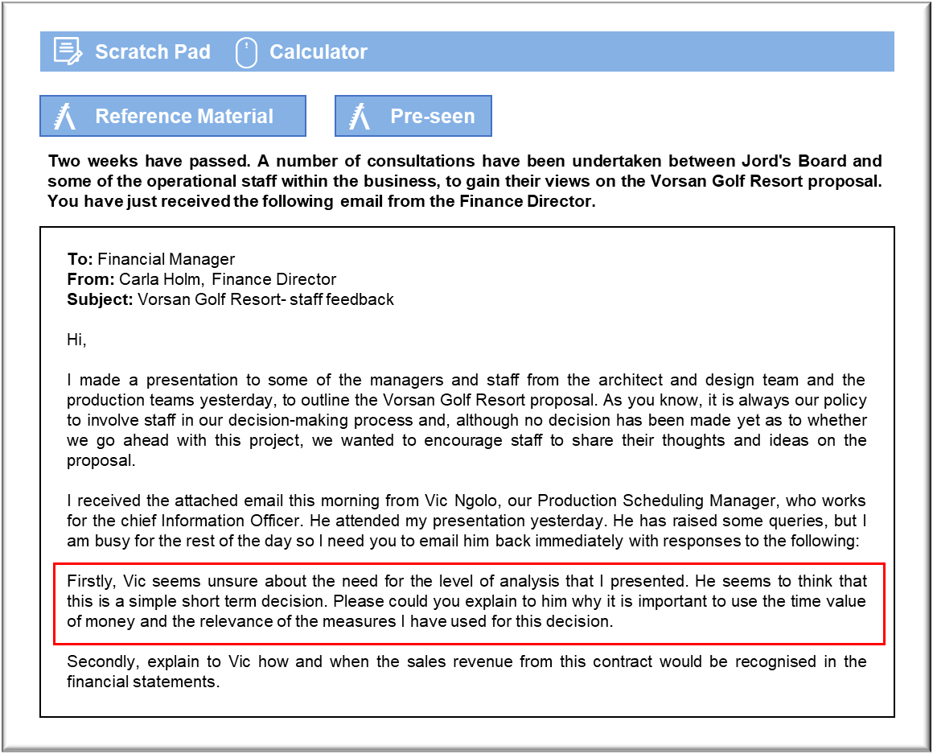

MANAGEMENT CASE STUDY MAY 2019 EXAM ANSWERS

Variant2 Task3
These answers have been provided by CIMA for information purposes only. The answers created are indicative of a response that could be given by a good candidate. They are not to be considered exhaustive, and other appropriate relevant responses would receive credit.

CIMA will not accept challenges to these answers on the basis of academic judgement.

The time value of money and the project appraisal methods used
Incorporating the time value of money into an investment appraisal decision takes
account of two factors. The first is that any investment involves committing funds that
have been raised and on which the entity is incurring a cost of finance. It is generally
appropriate to take that funding cost into account. These are relatively short term
projects, so the cost of capital will have less of an impact on the evaluation than if they
had a longer term, but it should also be borne in mind that Jord will be making a
significant investment. C$7 million is a significant outlay.
The other fact that the time value of money allows for is risk. Apart from the cost of the
funds, the entity is also incurring a risk that the project may fail. Evaluating the project
using the time value of money gives an insight into whether the expected returns are
sufficient to justify the risks that are being taken.
The principal measure based on the time value of money is net present value (NPV),
which has the advantage of linking the project’s anticipated outcome to the impact of
the project on shareholder wealth. On the basis of the table, accepting Phase 1 of the
project will increase shareholder wealth by C$2.501 million, taking account of both the
cost of capital and the risk.
IRR measures the return that is being earned on the funds invested in the project. Any
project that has an IRR that exceeds the required rate of return will have a positive
NPV. That means that Jord should accept Phase 1 if it can because it is delivering a
35% return on investment, while the company requires only 10% in order to cover the
cost of capital and the risk. The prospect of such a high return on investment may also
help the shareholders to understand the merits of accepting this risky project.
Discounted payback is more difficult to evaluate. In principle, it tells us that Jord will
be tying up funds for 1.5 years if it proceeds with Phase 1. That could be of some
interest in making strategic forecasts of cash flows, allowing for the need to raise
finance for other projects or generally for expansion.
Accounting treatment of the Vorsan project
You quite correctly noted that ‘revenues’ are not specifically mentioned in the
spreadsheet presented by Carla. These are in fact included within the ‘Cash inflow’
category.
Jord’s normal business of building pre-fabricated houses for individual customers is in
keeping with the activities of most businesses in that our costs and revenues are posted
to the statement of profit and loss as and when they occur. However, with this project,
an alternative treatment is likely to be required. This is because the costs and revenues
will not always be occurring within the same accounting period.
In terms of accounting for the delivery of the Vorsan project, we would need to
consider the application of IFRS 15 – Revenues from Contracts with Customers
(formerly covered by IAS 18), to determine how we account for the revenues received
in the Vorsan Golf Resort project, to ensure that the financial statements reflect a
position that is as close to reality as possible, leading with the matching concept.
The nature of this project may be different from most of our bespoke house building
projects because it will span more than one accounting period. In most cases, when we
deliver a bespoke manufactured home, we will take a down payment when the contract
is signed as a security, which will be recorded at that point as liability in the statement
of financial position. Costs and revenues will then be recorded in the period they occur.
To some extent, this revenue recognition issue currently occurs with our
manufacturing of homes but it is to a much lesser extent than this contract.
The accounting issue for the Vorsan project is therefore when the revenue and costs
associated with a longer-term contract should be recognised. In terms of the
accounting treatment of the Vorsan project, if we can estimate the outcome of the
contract reliably, then the revenues and costs should be recognised in the income
statement by reference to the stage of completion of the contract activity at the
reporting date. However, to satisfy this we must make sure that the following criteria
are met: firstly, the amount of revenue can be measured reliably; secondly, it is
probable that the economic benefits will flow to us; thirdly, the stage of completion at
the balance sheet date can be measured reliably; and fourthly, the costs incurred, or to
be incurred, in respect of the project can be measured reliably.
Phase I is likely to cause less difficulty for us and we should be able to simply account
for Revenue as Total contract revenue × % complete’, cost of sales as ‘Total expected
contract costs × % complete’ and Gross profit as ‘Total expected profit × % complete’.
This should help to ensure that the current profitability of the project is reflected fairly
in the financial statements.
Currently, Phase II is contingent on factors outside of our control and therefore it
would be prudent to not recognise this Phase of the project at all until there is certainty
that this will occur.

